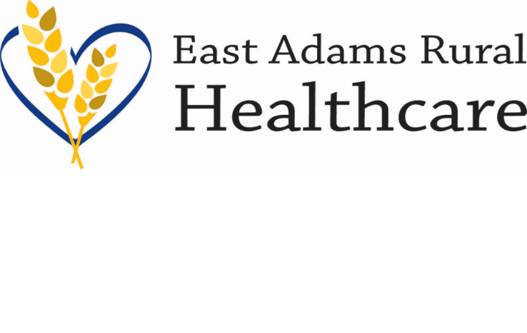

903 S Adams Ave. Ritzville, WA 99169

Office (509) 659-1200 Fax (509) 659-0632

[www.earh.org](http://www.earh.org)

NOTICE

NOTICE IS HEREBY GIVEN that a special meeting of the Board of Commissioners of Adams County Public Hospital District No. 2 will be held on Tuesday, February 27 at 12:00 pm. The purpose of the meeting is to do an Imaging department tour. The meeting will be held in the Imaging department.

________________________

John Kragt, Chair

Board of Commissioners

East Adams Rural Healthcare

Posted Time: 4:00 p.m.

Date: February 20, 2024